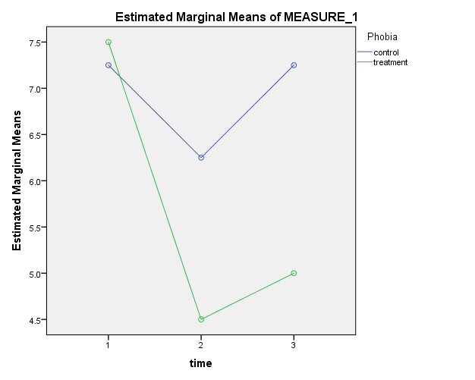Eight subjects, all with phobia, were randomly assigned to either a new treatment or a placebo. Phobia was measures prior to treatment/placebo, after, and 6 months later. A 2x3 mixed ANOVA, with treatment as the between subjects factor and time as the within subjects factor, was performed to investigate the initial and long term effectiveness of the new treatment. No evidence of spericity violations was found, Mauchly’s w=0.504 ~ χ2(2)=3.43, p=.18. A significant interaction between treatment and time was found, F(2, 12) = 3.94, p = .048. While the control group experiences a minimal reduction (M = 7.25 to 6.25) in phobia after viewing the inspirational talks (p=.050), phobia return to pre-treatment levels within 6 month (M = 7.25). Conversely, those who experienced the new treatment had a substantial initial reduction (M = 7.5 to 4.5) in phobia after treatment (p < .001) which persisted for at least 6 months (M = 5.0, p = .010).

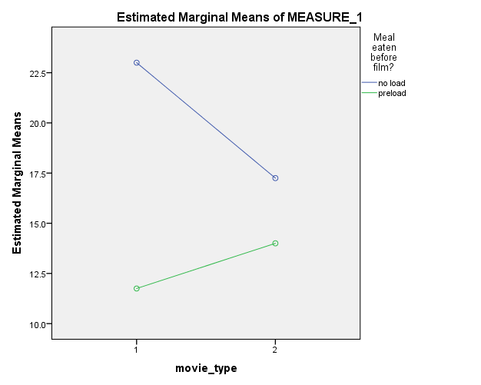Eight subjects were randomly assigned, half ate prior to watching movies, half did not. A 2x2 mixed ANOVA was preformed on the amount (ounces) of popcorn eaten during two movies. The within-subject factor was movie type, happy or fear, and the between-subjects factor was preload, yes or no. There was a significant interaction, F(1, 6)=139, p < .000022, such that hungry participants ate more in the happy film, but they ate the same in the fear film.

15B) #3d –

LSD = t(df) \* sqrt(2MS/n) =